Capstone Project:

Restaurant Management System

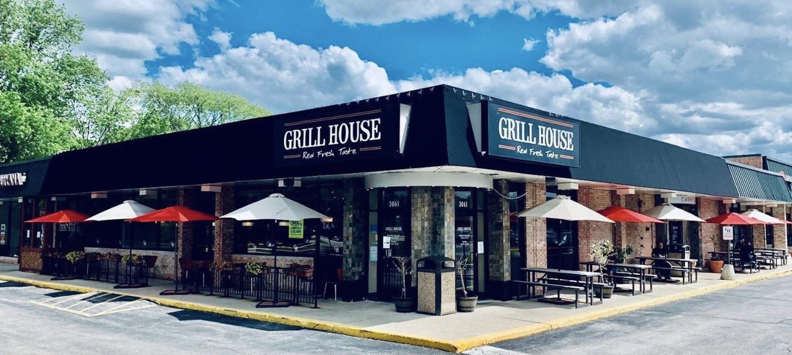

**Simplilearn PG-BA Course End Project - 1**

Prepared By – SINDU SAI KIRAN

**Project Overview**

A US celebrity chef James Oliver has his own chain of restaurants, ***The Grill House***, across different cities in the USA. He wanted to put a new Restaurant Management System to track the day-to-day management of his restaurant.

Currently they have a paper-based system for the same and this has many issues. Currently the orders were taken by the waiters on paper and a paper-based bill was presented to the customers.

All the bills were entered into an excel sheet by the manager at EOD to know the total sales and item wise sales for the day. Then reports were generated on excel to know trends and details like daily, weekly, and monthly sales. Which dishes were popular and which weren’t doing so well?

Restaurants need a system that will allow them to easily update their menu. The clients currently do not have a system that recognizes the different types of users such as managers, waiters, etc. and they would like to be able to limit the access of some options of the system to certain users.

**Business Analysis Core Concept Model for Restaurant Management System (RMS)**

**Visual Representation (Concept Map)**

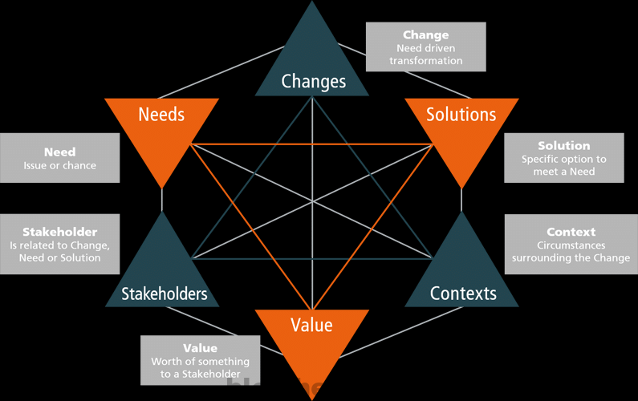

**1. Stakeholders**

* **External Stakeholders**
* **James Oliver (CEO)**: Oversees the overall operations and performance.
* **Managers**: Responsible for menu management, table reservations, and sales reporting.
* **Supplier: Payment Host:** Online payment gateway provider.
* **Regulator:** Government Regulatory bodies ensure privacy measure taken for data security as payment may include customer confidential information.
* **Waiters**: Handle order taking, bill generation, and customer interactions.
* **Customers**: Utilize the restaurant services and provide feedback.
* **Internal Stakeholders**
* **Project Manager:** Ensures that project is properly worked upon and entire team has all required resources needed for the project.
* **Implementation SME (Developers):** Responsible for the development of RMS in JAVA environment.
* **Testers:** Responsible to test the functionality of RMS software and ensure that its properly functioning.
* **Domain SME:** industry experts with best knowledge about the domain and help the team to understand the industry requirements and needs.
* **Operational Support:** They will assist the team with any operational hurdle during the development of system.

**2. Needs**

* **Efficiency**: Streamlined order taking and billing processes.
* **Data Accuracy**: Real-time sales tracking and reporting.
* **User Management**: Role-based access for different user types.
* **Customer Experience**: Quick service, easy payment options, and feedback collection.

**3. Context**

* **Order Management**: To transition from a manual paper-based system to an automated system to allow better day to day management.
* **Menu Management**: Menu changes have challenges; online menu is easy to edit and maintain.
* **Table Reservation**: Table reservation have been challenging, online reservation is easy use both for restaurant staff and customers.
* **Sales Reporting**: Lot of time and efforts spent to create day to day sales report, where as automated system reduces all the efforts and save time.

**4. Change**

* **Menu Management**: Items categorized into sections (Starters, Main Course, etc.). Managers easily create or update menu, easy to use menu in the RMS that could save waiters and managers’ time.
* **Sales Reporting**: Daily sales figures, item performance, customer payment methods. Automated generation of daily, weekly, and monthly sales reports.
* **Table Reservation**: managers easily reserve table. Reduce the Restaurant Operating cost.
* **Feedback Data**: Customer information and feedback collected via forms. Customers can choose dishes which are popular.

**5. Solutions**

* **Software Development**: Create a Java-based RMS that meets the defined requirements.
* **Payments**: Customer’s payments are accepted through a payment gateway
* **Training**: Provide training for staff to effectively use the RMS.
* **Support**: Establish a support system for ongoing maintenance and updates.

**6. Value**

* **Improved Efficiency**: Better availability of service as it reduces order processing time and errors. Can easily search menu by category. Efficiency in table reservation and tracking.
* **Enhanced Reporting**: Access to real-time sales and performance data.
* **Better Customer Experience**: Faster service and streamlined payment processes.
* **Data-Driven Decisions**: Managers can analyze sales trends and make informed decisions.

**Current As-Is State**

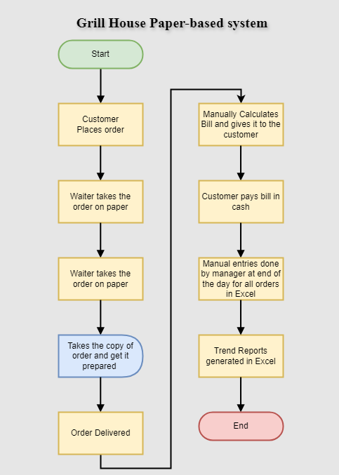

**Future State**

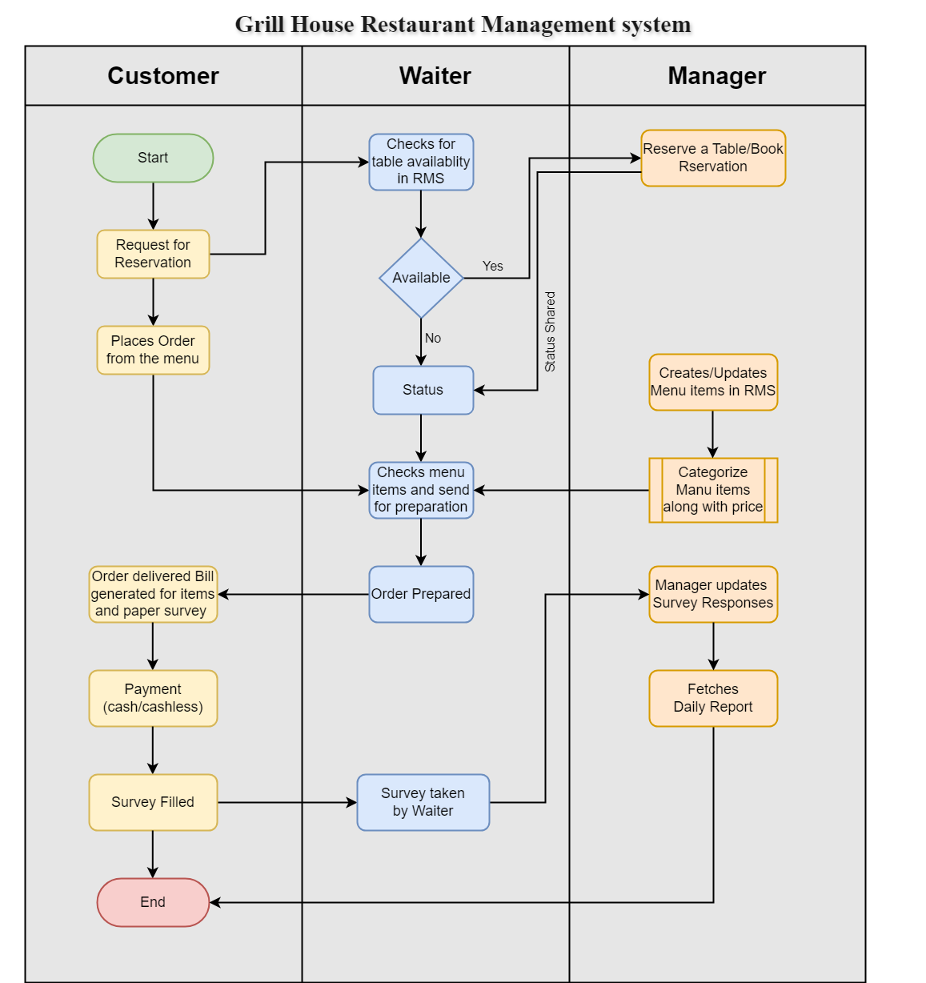

**Scope of Restaurant Management Software using Context Diagram**

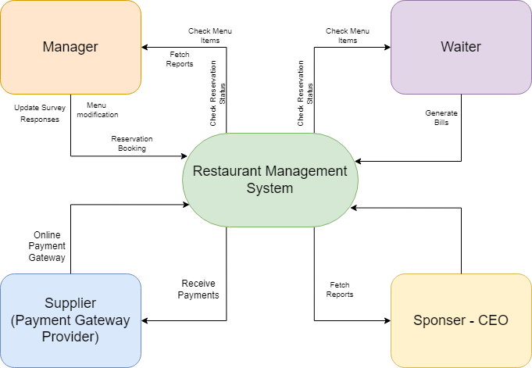

**Main Features that need to be developed:**

|  |  |
| --- | --- |
| **Management Reports** | Provide various reports for management, including :  Total sales of the day by using dine-in and domestic delivery customers separately.  Top 10 maximum bought dishes for the day.  Total sales for weekends and months.  List of dishes no longer bought inside the contemporary month. |
| **Login screen for different users / Password reset facility** | Login facility for waiters, managers, and the CEO (James Oliver) with a password change facility should be provided in the software. |
| **Payment Gateway** | Allow waiters to generate bills , tagging each invoice with the waiter's ID and table number.  Implement the functionality to just accept bills through cash or card via a payment gateway. |
| **Table Reservation** | Enable managers to reserve tables through the software program, stopping waiters from seating customers at reserved tables. |
| **Menu Creation/ Edition/ Deletion** | Creation of Menu and able to categorize it into various sections. Managers to have facility of creating/deleting/updating daily menu should be there in system. |
| **Menu Management** | Grouping of menu like Starters, Soups, Main Course, Desserts, and Drinks. |
| **Item Search** | Provide a search facility for each waiters and managers to locate objects inside the menu. |
| **Feedback Form** | Creation of a feedback form for customers. Capture of customer details such as name, address, mobile number, email, date of birth, and anniversary dates. Manual addition of feedback details by managers into the system. |

**In-Scope and Out-of-Scope items for the Software**

|  |  |
| --- | --- |
| **In-Scope** | **Out-of-Scope** |
| * Login/logout and registration along with password change facility. * Cash or cashless payment using card. * Generation of reports.  1. Total sales by dine-in customers. 2. Total sales by home delivery customers. 3. Total consolidated sales. 4. Top 10 most sold dishes. 5. Total sales on weekends. 6. Total sales every month. 7. List of dishes not sold in the current month. 8. Total sales across all cities. 9. Total sales for each city.  * Menu creation/updating and deletion by authorized person. * Authorized access and limitations based on job profile and authorization. * Manual entry of feedback survey responses. * Listing of menu items in categorized way along with price of each item. * Ability for waiters and managers to search items in the menu * Table reservation and layout information. * Electronic bill generation. * Tagging of the generated bill to the waiter and table number for generating the bill. | * Reservation cannot be done by customer directly. * Payment can only be accepted in cash or via card. No other digital method is accepted. * Waiters can’t book reservation for the customer. * Limitation of feedback survey to paper-based format only. * Automated data entry from feedback forms. |

**Requirements Classification**

**Business Requirements:**

* The main requirement is to develop a restaurant management system to automate the management in the restaurant and also to identify the level of access for each user based on the Job role so as to limit the functionality of the system to certain users.

**Stakeholder Requirements:**

Restaurant Management:

* Management wants certain reports at the end of the day. Please give the report formats for the following reports:

1. Total sales of the day by dine in customers
2. Total sales of the day by home delivery customers
3. Total sales of the day (home delivery and dine in customers consolidated)
4. Name the top 10 most sold dishes for the day
5. Total sales every weekend (to be done by inputting the dates)
6. Total sales every month (to be done by inputting the dates)
7. List of dishes not sold in the current month (this is to phase out dishes that
8. customers are not ordering)
9. Total sales across all cities
10. Total sales for each city

* Managers should be able to create/update/delete menu and this functionality is limited to managers only.
* Waiters and managers should be able to search items in the menu using the search facility.
* Every waiter and manager should have access to the software.
* Only managers should be able to book reservation. Whereas The waiters shall look into the software to determine which tables need to be reserved.

CEO (James Oliver):

* James Oliver would like a feedback form (paper) to be given to every customer. This form shall capture details like name, address, mobile number, email, date of birth, anniversary dates of the customers, and their feedback. These details shall be added by the manager manually into the system.

|  |  |
| --- | --- |
| **Functional Requirements** | **Non-Functional Requirements:** |
| **Login screens for different users**   * When customer clicks on login, one should be able to view details/perform actions based on their respective roles.   **Search Facility**   * Waiters and managers can search for items in the menu.   **Table Reservation**   * Managers can reserve tables. * Waiters cannot seat anyone on reserved tables.   **Feedback Form**   * Manager should be able to enter info like Name, Address, Email, DOB, Mobile No into the system.   **Menu Management**   * Managers can create, edit, and delete menu items. * Menu items are categorized into   o Starters  o Soups  o Main Course  o Desserts  o Drinks   * Each menu item includes its name and price.   **Bill Generation**   * Waiters generate bills per table, tagging them with the waiter's name and table number. * Bills include items ordered and their respective prices.   **Payment Gateway**   * Integration of payment gateway for cash and card transactions.   **Management Reports**   * Daily reports: * Total sales by dine-in customers. * Total sales by home delivery customers. * Total consolidated sales. * Top 10 most sold dishes. * Periodic reports: * Weekend sales. * Monthly sales. * List of dishes not sold in the current month. * Total sales across all cities. * Total sales for each city. | **Security**   * Secure login mechanisms/system to protect user accounts. * Encryption of sensitive customer information.   **Scalability**   * Ability to handle increased menu items and customer transactions as the business grows.   **Maintainability**   * Well-documented codebase for easy maintenance and future updates. * Modular design to facilitate addition of new features.   **Availability**   * System should be available during Business hours of restaurant.   **Usability**   * Good UI/UX: user interface for easy navigation. * Quick response time for searches and bill generation.   **Performance**   * Efficient database management for quick retrieval of menu items and customer information. |

**Transitional Requirements:**

* Provide relevant training and knowledge to the staff for the newly developed tool in order to make it fully functional and make transition from paper-based tracking to automated tracking in restaurant.

**System environment**:

* We are going to be creating and maintaining the program in Java. We chose Java because it will not change much over time, and if we make it well, there will be very little maintenance to be done on the code.

**Wireframing**

**Menu Update/Create Mock Screen:**

**Table Reservation Mock Screen:**

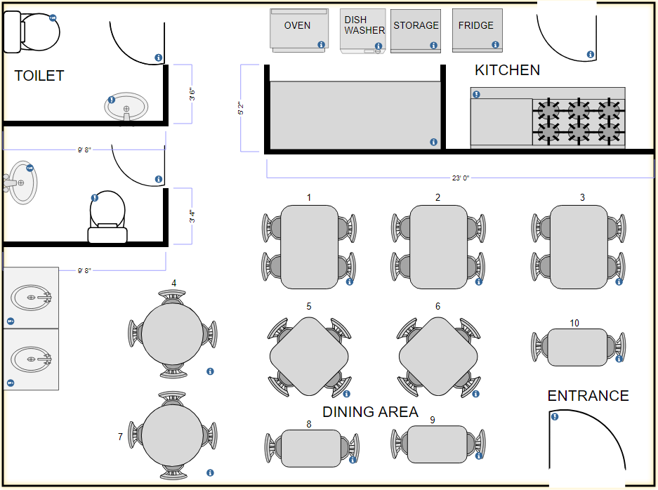

Tableau Project Task:

**Future State**

**Client has given them the following requirements:**

1. System should be able to create a menu. The menu should be categorized into following sections:

* Starters
* Soups
* Main Course
* Desserts
* Drinks

Every item in the menu stored should be categorized into any one of the above heads. Each item should be saved in the system along with its price. For example, Green Thai Curry - price $12, Pasta – $10 and so on. This menu should be created and edited by the managers only. They should be able to add new items, delete existing items, as well as create new menus from scratch.

1. Waiters and managers should be able to search items in the menu using the search*facility*.
2. Every waiter and manager should have access to the software. Waiters shall use this system for generating the bill table wise. Every bill shall be tagged to the waiter generating it and the table number. Waiters cannot edit the menu. Waiters shall use the system only to generate bills.
3. The system should be able to reserve tables. This reservation would be done by managers *only*. The waiters shall not seat anyone on the tables reserved. The waiters shall look into the software to determine which tables need to be reserved. The table layout is to be stored in the system.
4. Management wants certain reports at the end of the day. Please give the report formats for the following reports:

* Total sales of the day by dine in customers
* Total sales of the day by home delivery customers
* Total sales of the day (home delivery and dine in customers consolidated)
* Name the top 10 most sold dishes for the day
* Total sales every weekend (to be done by inputting the dates)
* Total sales every month (to be done by inputting the dates)
* List of dishes not sold in the current month (this is to phase out dishes that customers are not ordering)
* Total sales across all cities
* Total sales for each city

1. Login for waiters, managers, and James Oliver (CEO). *Change password* facility to be offered.
2. Customers can pay by cash or card. There should be a payment gateway on the system.
3. System should be able to generate the bill.
4. James Oliver would like a feedback form (paper) to be given to every customer. This form shall capture details like name, address, mobile number, email, date of birth, anniversary dates of the customers, and their feedback. These details shall be added by the manager manually into the system.

**You can download the data set, variable description, and menu from here.** - [](https://lms.simplilearn.com/user/project/download-attachment?file=1592301794_datasethospitability.xlsx)

**Project Task: Week 1 and Week 2 (This is on the Business Analysis concepts taught)**

1. Identifying Stakeholders – Create a list of Stakeholders (as taught in Business Analysis Planning and Monitoring Knowledge Area)
2. Create As-Is and Future Process map (using flowcharts). You can use any of the popular tools in the market like Microsoft Visio, Lucidchart, Creately, Pidoco, or Balsamiq
3. As a Business Analyst working on this project, find out the scope of the Restaurant Management Software. Write down the main features that need to be developed.
4. Write the in-scope and out-of-scope items for this software.
5. Write out the business requirements, both functional and nonfunctional requirements.
6. Draw wireframes or mock screens for two of the features namely *menu creation* and *table reservation*. Use the technique prototyping or wireframing that is taught in the training. You can use any of the wireframing tools like Microsoft PowerPoint, Microsoft Word, Balsamiq, Sketch, Adobe XD, Adobe ILLustrator, Figma, UXPin, InVision Studio, Invision Freehand, or Moqups.

**Project Task: Week 3 (This is on the Tableau concepts taught)**

1. Create a dashboard for senior management to view sales of restaurants for the last six months. Make assumptions as appropriate and create the dashboard using your own mock data.
2. Create a dashboard to show which zone (Zone 1, 2, 3, or 4) has highest sales. Make assumptions as appropriate and create the dashboard using your own mock data.

**Excel**

Question 1:

|  |  |  |  |  |  |  |  |
| --- | --- | --- | --- | --- | --- | --- | --- |
| Restaurant ID | City | Jan | Feb | Mar | Apr | May | June |
| 1200333 | Chicago | 18,225 | 15,184 | 98,984 | 1,500 | 71,111 | 7,889 |
| 1200352 | New York | 15,184 | 15,845 | 41,545 | 1,622 | 15,151 | 15,184 |
| 1200669 | Seattle | 15,845 | 11,112 | 15,184 | 15,184 | 78,787 | 15,845 |
| 1200888 | Washington | 11,112 | 15,455 | 15,845 | 15,845 | 10,000 | 11,112 |
| 1200989 | Kansas City | 15,455 | 15,454 | 11,112 | 11,112 | 20,000 | 10,000 |
| 1200444 | San Jose | 15,454 | 18,498 | 15,455 | 15,184 | 18,498 | 20,000 |
| 1200358 | Dallas | 78,888 | 48,211 | 15,454 | 15,845 | 48,211 | 15,000 |
| 1200289 | Miami | 48,211 | 16,595 | 18,498 | 11,112 | 16,595 | 15,151 |
| 1200739 | New Orleans | 16,595 | 15,487 | 48,211 | 78,787 | 45,484 | 44,544 |
| 1200498 | Phoenix | 15,487 | 56,451 | 16,595 | 15,487 | 15,184 | 1,515 |
| 1200789 | Madison | 56,451 | 78,451 | 15,487 | 87,844 | 15,845 | 5,655 |
| 1200432 | Jersey City | 12,121 | 14,414 | 56,451 | 89,894 | 11,112 | 8,985 |

1. Create a bar graph for San Jose, Madison, and New York showing the sales. Label the chart drawn correctly so that senior management gets a clear report of sales.
2. Arrange the data above in excel in an ascending and descending order for each city.

Question 2:

1. In the above chart for restaurant ID 1200789, find the sales for the month of June
2. In the above chart for restaurant ID 1200739, find the sales for the month of April
3. In the above chart for restaurant ID 1200352, find the sales for the month of January